PROJECT DESIGN PHASE-II
Data Flow Diagrams & User Stories
Date | 02 October 2026
Team ID | SWTID-2026-9699
Project Name | LegalEase – AI-Powered Legal Document Generator
Maximum Marks | 4 Marks

Data Flow Diagrams
A Data Flow Diagram (DFD) represents how information moves through LegalEase, how it is processed, and how the generated document is returned to the user. The diagrams below are based on the supplied project documentation and code.

DFD Level 0 — Context Diagram
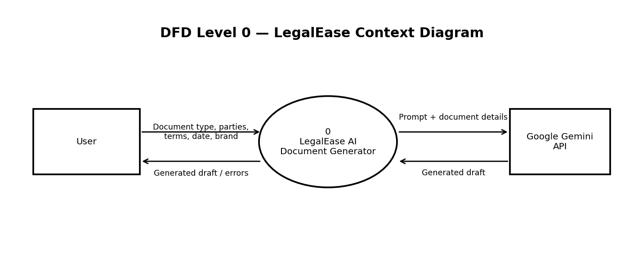
The user submits document details to LegalEase. The application sends a prompt and the supplied details to the Google Gemini API, receives generated draft text, and returns the draft or an error to the user.

DFD Level 1 — Document Generation Flow
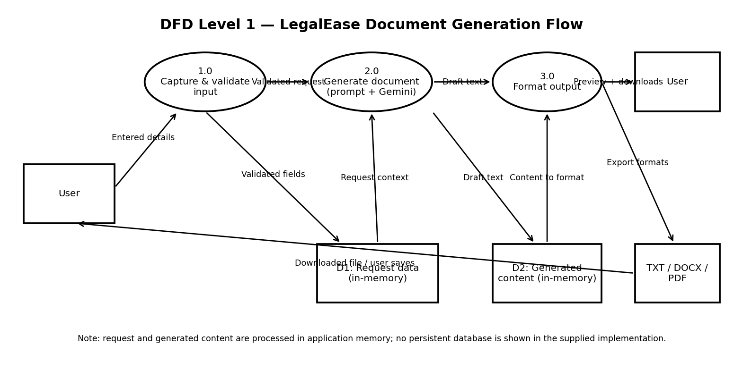
Processing sequence: (1) capture document type, parties, terms, optional effective date, and optional brand name; (2) validate required fields; (3) construct the prompt and request a first draft from Gemini; (4) format the result as TXT, DOCX, and PDF; and (5) display the draft and provide download options. The supplied implementation does not show a persistent database.
Safety note: LegalEase generates a first draft only. It must not be represented as legal advice or guaranteed legally valid; missing details should remain placeholders and the draft should be reviewed by a qualified professional.

User Stories
The following user stories describe the user-facing functions supported by the supplied LegalEase documentation and code. Priorities and sprint assignments are proposed for planning; they are not evidence of completed releases.
User Type | Functional Requirement (Epic) | User Story Number | User Story / Task | Acceptance Criteria | Priority | Release
Customer (Web user) | Document selection | USN-1 | As a user, I can select the type of legal document I want to prepare. | The user can select from the document types offered by the interface: NDA, service, employment, lease, partnership, freelance, or general legal agreement. | High | Sprint-1
Customer (Web user) | Enter document details | USN-2 | As a user, I can enter the parties and terms for my legal document. | The form accepts parties and terms; required fields are checked before generation. | High | Sprint-1
Customer (Web user) | Enter optional details | USN-3 | As a user, I can provide an effective date and optional brand name. | The effective date and brand name can be supplied when applicable; they are passed to the document-generation flow. | Medium | Sprint-1
Customer (Web user) | Generate draft | USN-4 | As a user, I can generate a first draft from the details I entered. | The application submits the request to the generation service and displays the returned draft when generation succeeds. | High | Sprint-1
Customer (Web user) | Review draft | USN-5 | As a user, I can review the generated legal document before downloading it. | The generated document text is displayed for review and is identified as an AI-generated first draft. | High | Sprint-1
Customer (Web user) | Download document | USN-6 | As a user, I can download the generated document in a format I can use. | Download options are provided for TXT, DOCX, and PDF. | High | Sprint-1
Customer (Web user) | Handle generation errors | USN-7 | As a user, I want to know when document generation fails. | If generation raises an error, the application returns or displays an error rather than presenting a failed result as a completed draft. | Medium | Sprint-2
Customer (Web user) | Safe draft generation | USN-8 | As a user, I want missing information to be clearly identified instead of invented. | The generation instructions prohibit fabricated names, dates, amounts, laws, jurisdictions, and signatures; missing details use placeholders. | High | Sprint-1

Scope and Evidence Note
The DFDs reflect the documented Streamlit frontend, FastAPI endpoint (POST /api/generate), Gemini generation service, and TXT/DOCX/PDF export flow. No login, customer-care role, administrator workflow, or persistent database is included because these are not shown in the supplied project materials. Sprint and priority values are planning suggestions. Verify the running application before marking any story as completed.

